ROCKCITY HOMES LIMITED
Affordable Homes, Made Simple.
COMPANY PROFILE
Real Estate Development & Investment

INTRODUCTION
Rockcity Homes Limited is a dynamic real estate development and investment company dedicated to creating residential and commercial properties that respond to Nigeria's growing demand for secure, functional, and economically viable real estate. The Company undertakes the planning, construction, marketing, and management of property developments, delivering integrated solutions that serve individuals, businesses, and institutional investors.
As Nigeria continues to experience rapid urbanization and increasing demand for housing, Rockcity Homes is strategically positioned to help address the nation's housing deficit through carefully planned estates, transparent business practices, and accessible homeownership opportunities. By combining reliable land documentation, modern infrastructure, and practical development strategies, the Company creates communities that promote security, convenience, and long-term economic benefits for residents and investors alike.
This Company Profile presents an overview of Rockcity Homes Limited, outlining the Company's corporate identity, operational capabilities, service offerings, strategic direction, and approach to delivering real estate solutions that inspire confidence among homeowners, investors, financial institutions, and development partners.

ABOUT US
Rockcity Homes Limited is a Nigerian real estate development and investment company focused on transforming land into well-planned residential, commercial, and mixed-use communities across the country's emerging growth corridors. Headquartered in Abuja, the Company provides end-to-end property solutions spanning land acquisition, estate planning, construction, property administration, and investment advisory.
Our operational approach is shaped by valuable industry experience gained through collaborations on projects involving Baymax Real Estate Development in Northern California, Sahara Properties in Abuja, and Amen Estate in Lagos State. These engagements have strengthened our expertise in project planning, construction management, risk control, client engagement, and corporate governance while reinforcing internationally recognised development practices.
Rockcity Homes follows a structured development model built on verified land titles, phased project execution, efficient infrastructure delivery, and flexible ownership options that broaden access to property investment. Through disciplined project management, sound financial planning, and productive industry collaborations, the Company delivers developments that generate enduring economic returns for homeowners, corporate organisations, diaspora investors, and institutional clients.
With a clear focus on responsible expansion and operational sustainability, Rockcity Homes continues to strengthen its market presence by developing vibrant communities, broadening investment opportunities, and contributing to Nigeria's urban and economic transformation.

MISSION STATEMENT
To deliver thoughtfully planned residential and commercial developments that provide secure property ownership, attractive investment opportunities, and thriving communities through responsible business practices, sound project execution, and client-focused solutions.

VISION STATEMENT
To become a leading real estate development company in Nigeria and a recognised name across Africa for shaping vibrant communities, expanding access to property ownership, and driving meaningful urban transformation.

AIM AND OBJECTIVES

Aim
To develop modern real estate projects that promote accessible homeownership, support economic growth, and generate sustainable returns for investors and stakeholders.

Objectives
- Develop at least three residential estates in major Nigerian cities within five years.
- Deliver over 500 housing units within the same period.
- Expand operations into Abuja, Lagos, Port Harcourt, Enugu, and Asaba.
- Build productive relationships with local and international investment institutions and development stakeholders.
- Establish a robust digital marketing and property sales platform that enables clients to access our services from anywhere in the world.
- Strengthen operational capacity through efficient project planning, sound financial management, and continuous organisational development.

CORE VALUES

Integrity
We uphold honesty, transparency, and ethical conduct in land transactions, pricing, documentation, and every business engagement.

Accountability
We take ownership of our decisions, honour our obligations, and remain responsible for every commitment made to clients, partners, and stakeholders.

Innovation
We embrace forward-thinking ideas, modern planning techniques, and digital solutions that improve the way we develop, market, and manage real estate projects.

Client Focus
We place the needs of our clients at the centre of our operations, delivering practical solutions, responsive support, and a seamless property acquisition experience.

Operational Discipline
We maintain structured planning, efficient execution, prudent resource management, and strong corporate governance to ensure consistency across every project.

Responsible Development
We create communities that balance economic growth, environmental stewardship, and social wellbeing, ensuring developments remain beneficial for present and future generations.

OUR SERVICES
ROCKCITY HOMES LIMITED provides integrated real estate development and investment solutions that address the growing demand for quality housing, secure property ownership, and sustainable community development across Nigeria. Our services are designed to support individuals, families, corporate organizations, institutional investors, government agencies, and members of the Nigerian diaspora by delivering professional, transparent, and innovative real estate solutions from concept to completion.

RESIDENTIAL ESTATE DEVELOPMENT
Residential estate development is the cornerstone of Rockcity Homes Limited's business. We plan, design, construct, and deliver modern residential communities that integrate functional infrastructure, contemporary architecture, and thoughtfully designed living spaces. Every project is developed to provide a safe, comfortable, and well-connected environment that supports both homeowners and property investors.
Nigeria continues to face a significant housing deficit driven by rapid population growth, urban migration, infrastructure gaps, and limited access to affordable housing finance. Many residential developments are affected by inadequate planning, poor drainage systems, unreliable utilities, insufficient community amenities, and weak maintenance frameworks, reducing their long-term desirability and investment potential.
Rockcity Homes responds to these challenges through comprehensive estate planning that incorporates durable road networks, efficient drainage, dependable water supply, electricity infrastructure, recreational facilities, landscaped green areas, and integrated security systems. Each project is executed in accordance with statutory planning requirements, engineering specifications, and established construction standards to ensure functionality, durability, and operational efficiency.
Our phased delivery model and flexible ownership options enable a wider range of buyers to access residential property while promoting efficient project execution and prudent risk management. Our developments are designed to serve first-time homebuyers, growing families, corporate organisations, and diaspora investors seeking dependable property assets with strong appreciation potential.

Scope of Services
- Estate Master Planning
- Residential Estate Development
- Gated Community Development
- Luxury Housing Projects
- Affordable Housing Estates
- Mixed-Income Housing Developments
- Infrastructure Development
- Smart Community Development

LAND SALES & DOCUMENTATION
Land ownership remains one of the most significant forms of investment in Nigeria. However, acquiring land is frequently complicated by title disputes, multiple ownership claims, fraudulent transactions, and incomplete documentation, exposing buyers to unnecessary financial and legal risks.
Rockcity Homes provides comprehensive land acquisition and documentation services that enable individuals, corporate organisations, and investors to purchase property with confidence. Every property undergoes rigorous due diligence to confirm ownership, validate title documents, verify statutory approvals, and ensure compliance with applicable land administration regulations before it is presented to prospective buyers.
Working closely with licensed surveyors, legal practitioners, and relevant government authorities, we facilitate every stage of the acquisition process—from preliminary verification to the completion of statutory documentation—ensuring transparency, accuracy, and regulatory compliance.
Our structured approach minimises uncertainty, protects our clients' interests, and provides the legal assurance required to make informed and secure property investment decisions.

Scope of Services
- Land Acquisition
- Land Verification
- Title Investigation
- Survey Plans
- Certificate of Occupancy Processing
- Governor's Consent
- Deed of Assignment
- Land Registration
- Property Documentation Advisory

PROPERTY DEVELOPMENT & CONSTRUCTION
Rockcity Homes provides integrated property development and construction services for residential, commercial, and mixed-use projects. From site evaluation and conceptual planning to engineering, construction, and final handover, we oversee every phase of project delivery with technical precision and disciplined execution.
Nigeria's construction sector continues to face challenges such as inconsistent workmanship, project delays, escalating costs, and inadequate site coordination. These issues often result in avoidable defects, extended completion periods, and reduced investor confidence.
To address these challenges, Rockcity Homes adopts a structured project delivery framework built on detailed planning, efficient procurement, prudent cost control, rigorous site supervision, and coordinated execution throughout every stage of construction.
Working alongside experienced architects, engineers, quantity surveyors, and construction specialists, we deliver developments that are structurally reliable, compliant with regulatory requirements, and completed in accordance with approved specifications, budgets, and project schedules.

Scope of Services
- Residential Construction
- Commercial Construction
- Mixed-Use Developments
- Project Planning
- Engineering Coordination
- Construction Supervision
- Infrastructure Development
- Renovation and Redevelopment

PROPERTY MANAGEMENT
Effective property management is essential for protecting real estate assets, maintaining operational efficiency, and supporting consistent financial performance. Inadequate maintenance, weak facility administration, ineffective tenant management, and poor operational oversight can reduce occupancy levels and diminish the overall performance of a property.
Rockcity Homes provides comprehensive property management solutions for residential and commercial developments, ensuring that properties remain well-maintained, efficiently operated, and attractive to both occupants and investors throughout their service life.
Our services encompass facility maintenance, tenant administration, rent management, security coordination, landscaping, cleaning services, utility oversight, and scheduled maintenance programmes designed to preserve the physical condition and operational performance of every property under our care.
Our objective is to relieve property owners of day-to-day operational responsibilities while creating environments that encourage tenant retention, optimise occupancy levels, and protect the long-term performance of their investments.

Scope of Services
- Estate Management
- Facility Management
- Rent Administration
- Tenant Management
- Preventive Maintenance
- Landscaping
- Cleaning Services
- Security Coordination
- Utility Management

REAL ESTATE INVESTMENT CONSULTING
Sound real estate investment decisions depend on reliable market intelligence, financial evaluation, and a clear understanding of investment opportunities. Many investors experience avoidable losses due to inadequate due diligence, inaccurate market assessments, and poorly structured acquisition strategies.
Rockcity Homes provides real estate investment consulting services that equip clients with the insights required to identify viable opportunities, manage potential risks, and make informed investment decisions. Our advisory solutions serve private investors, corporate organisations, financial institutions, and members of the Nigerian diaspora seeking to establish or expand their property portfolios.
Our team conducts feasibility studies, market assessments, investment appraisals, portfolio evaluations, risk analysis, and financial modelling to support informed decision-making throughout the investment lifecycle.
From opportunity identification to acquisition planning and portfolio expansion, we help clients develop investment strategies that strengthen asset performance and support sustainable wealth creation.

Scope of Services
- Investment Advisory
- Feasibility Studies
- Market Research
- Financial Analysis
- Portfolio Development
- Risk Assessment
- Property Acquisition Support
- Investment Planning

JOINT VENTURE DEVELOPMENTS
Joint venture arrangements provide an effective framework for unlocking the development potential of land while combining the financial, technical, and operational strengths of multiple stakeholders. Rockcity Homes works with landowners, investors, financial institutions, and corporate organisations to structure mutually beneficial development partnerships.
Many landowners possess strategically located assets but require experienced development partners to transform them into commercially viable projects. Similarly, investors often seek reliable opportunities supported by competent project execution and transparent governance.
Our joint venture model brings together land, funding, technical expertise, and project coordination under clearly defined legal and commercial agreements that protect the interests of every participating party.
Through careful planning, equitable commercial structures, and disciplined project management, we facilitate large-scale developments while optimising available resources and creating shared economic benefits for all participants.

Scope of Services
- Landowner Partnerships
- Investment Partnerships
- Project Structuring
- Development Management
- Financial Coordination
- Profit Sharing Models
- Joint Venture Advisory

AFFORDABLE HOUSING PROJECTS
Rockcity Homes supports national efforts to address Nigeria's housing deficit by developing residential communities that broaden access to homeownership without compromising structural integrity, functionality, or essential infrastructure.
Millions of Nigerians continue to face barriers to property ownership due to rising construction costs, limited mortgage accessibility, and increasing urban housing demand. Addressing these challenges requires practical planning, efficient resource utilisation, and flexible financing approaches that reflect the realities of today's housing market.
Our affordable housing initiatives combine cost-efficient construction methods, carefully planned infrastructure, and structured payment options that enable low- and middle-income earners to acquire homes through realistic ownership pathways.
Working alongside government institutions, financial organisations, and development agencies, Rockcity Homes contributes to expanding housing availability, strengthening urban communities, and supporting broader economic development across Nigeria.

Scope of Services
- Affordable Housing Development
- Government Housing Projects
- Public-Private Partnerships
- Social Housing Schemes
- Worker Housing Projects
- Community Development
- Housing Finance Support
- Flexible Homeownership Solutions

WHY CHOOSE US
- Experienced leadership and project management, drawn from exposure to established developers across three markets.
- Strong strategic partnerships with land owners, contractors, and capital partners.
- Transparent, documented business practices that protect buyers against title fraud and delivery risk.
- Flexible payment plans that open homeownership to buyers without access to formal mortgage financing.
- High-quality infrastructure and modern estate planning designed for long-term asset value.
- A direct, responsive relationship with clients from first inquiry through post-handover property management.

OUR LEGACY
Rockcity Homes Limited was established on practical industry experience gained through participation in projects involving Baymax Real Estate Development in Northern California, Sahara Properties in Abuja, and Amen Estate in Lagos State. These engagements provided valuable insight into modern estate planning, disciplined project execution, regulatory compliance, and effective stakeholder management.
Rather than relying solely on conventional development models, the Company was founded with a clear objective: to deliver real estate projects built on transparent land transactions, disciplined execution, and dependable client relationships. This practical foundation continues to shape our approach to property development and positions Rockcity Homes as a company focused on creating enduring opportunities for homeowners, investors, and development partners.

LEADERSHIP
The leadership of Rockcity Homes Limited provides the strategic direction and organisational oversight required to support the Company's long-term growth and operational effectiveness. Guided by sound decision-making, responsible governance, and a forward-looking outlook, the leadership team ensures that every project aligns with the Company's business objectives and stakeholder expectations.
Drawing on expertise across real estate development, engineering, construction, finance, investment, legal compliance, marketing, and business administration, our management team promotes collaboration, operational efficiency, prudent risk management, and responsible resource allocation throughout the organisation.
As the Company expands, its leadership framework is designed to evolve into a fully integrated management structure capable of supporting larger developments, broader geographic operations, and stronger institutional capacity while maintaining consistency in performance and accountability.

MR. LUCKY OSUAGWU

DIRECTOR, ROCKCITY HOMES LIMITED
Mr. Lucky Osuagwu is a visionary entrepreneur, real estate developer, and business executive with a strong commitment to transforming Nigeria's real estate sector through innovative, sustainable, and investment driven property developments. As the Director of Rockcity Homes Limited, he provides strategic leadership for the Company's operations, business development, investment initiatives, and long-term growth strategy.
With extensive experience in real estate development, project management, and property investment, Mr. Osuagwu has established a reputation for professionalism, integrity, and excellence in delivering projects that create lasting value for homeowners, investors, and communities. His leadership philosophy is founded on transparency, quality, innovation, and customer satisfaction, positioning Rockcity Homes Limited as a trusted partner in Nigeria's rapidly expanding real estate market.
Mr. Osuagwu has gained valuable industry experience through collaborations on projects involving Baymax Real Estate Development in Northern California, Sahara Properties in Abuja, and Amen Estate in Lagos State. These professional engagements have strengthened his expertise in estate planning, residential development, project execution, investment structuring, and the delivery of modern communities that meet international standards of quality and sustainability.
Under his leadership, Rockcity Homes Limited is focused on addressing Nigeria's growing housing deficit by delivering professionally planned residential estates, affordable housing developments, commercial properties, and strategic real estate investment opportunities. The Company adopts a disciplined development approach built on verified land acquisition, quality construction, flexible ownership solutions, and sound corporate governance to ensure long term value creation for clients and investors.
Mr. Osuagwu is passionate about building strategic partnerships with financial institutions, government agencies, institutional investors, private organizations, and development partners to accelerate housing delivery and promote sustainable urban development across Nigeria. His ability to identify emerging market opportunities, build strong stakeholder relationships, and execute projects with professionalism continues to drive the Company's growth and competitive advantage.

Areas of Expertise
- Real Estate Development and Estate Planning
- Property Development and Project Management
- Real Estate Investment and Portfolio Development
- Strategic Business Development
- Investment Structuring and Joint Venture Partnerships
- Residential and Commercial Property Marketing
- Land Acquisition, Verification, and Documentation
- Client Relationship Management
- Real Estate Investment Advisory
- Corporate Strategy and Organizational Leadership
As Director of Rockcity Homes Limited, Mr. Lucky Osuagwu remains committed to delivering developments that combine quality, affordability, innovation, and sustainability while maintaining the highest standards of integrity, accountability, and corporate governance. His vision is to build one of Nigeria's most trusted real estate companies and contribute meaningfully to reducing the nation's housing deficit through developments that improve lives, strengthen communities, and generate sustainable long-term value for all stakeholders.

STRATEGIES FOR GROWTH AND SUCCESS

Rockcity Homes Limited is committed to achieving sustainable growth through strategic planning, operational excellence, innovation, and strong partnerships. Our growth strategy focuses on expanding our presence in high potential markets, delivering quality developments, maintaining the highest standards of professionalism, and creating long term value for clients, investors, and stakeholders.
Year | Period | Key Milestones
Year 1 | 2026 | Strengthen the Company's brand, acquire strategic land, establish key partnerships, and commence the first flagship residential estate.
Year 2 | 2027 | Continue construction activities, deliver the first phase of housing units, and expand operations into a second state.
Year 3 | 2028 | Launch mixed use developments and affordable housing projects while strengthening the Company's market presence.
Year 4 | 2029 | Expand into additional cities, attract institutional and diaspora investors, and diversify revenue streams.
Year 5 | 2030–2031 | Establish ROCKCITY HOMES as a nationally recognized real estate developer with multiple completed projects and sustainable recurring income.

CRAFTSMANSHIP AND QUALITY
Quality control at Rockcity Homes is applied at every stage of development, from land verification through final handover, to protect both the durability of what is built and the trust of the people who buy it.
- Use of vetted, experienced contractors and tradespeople on every project.
- Adherence to approved architectural and engineering designs, with no unauthorized deviations during construction.
- Use of quality-assured building materials sourced from reputable suppliers.
- Milestone-based site inspections at each phase of construction, from foundation to finishing.
- Defect-liability follow-up after handover to address any post-completion issues promptly.

HEALTH, SAFETY, SECURITY AND ENVIRONMENT (HSSE)
Rockcity Homes Limited is committed to maintaining the highest standards of health, safety, security, and environmental responsibility across all our projects. We strive to provide safe working environments, secure developments, and sustainable communities while complying with all applicable regulatory requirements.
Our HSSE commitment includes:
- Health and Safety: Promoting safe work practices through the use of appropriate personal protective equipment (PPE), regular safety awareness, and strict adherence to site safety procedures.
- Security: Integrating effective security measures, including controlled site access, perimeter fencing, adequate lighting, and estate security planning.
- Environmental Responsibility: Incorporating proper drainage systems, waste management practices, and green spaces to promote sustainable and environmentally friendly developments.
- Regulatory Compliance: Ensuring full compliance with relevant building codes, health and safety standards, and environmental regulations throughout every stage of project development.

STRATEGIC PARTNERS
Rockcity Homes Limited collaborates with reputable professionals and organizations to ensure the successful delivery of quality real estate projects. Our strategic partnerships strengthen our technical capacity, operational efficiency, and commitment to delivering value to our clients and investors.
Our network of partners includes:
- Landowners and verified title holders
- Licensed surveyors and legal consultants
- Architects, engineers, and construction contractors
- Financial institutions and investment partners
- Real estate consultants and sales professionals
- Government agencies and regulatory authorities

PROJECT COLLABORATIONS

Experience Gained Through Strategic Development Partnerships
Our involvement in collaborative real estate developments has strengthened our expertise in estate planning, project coordination, construction management, quality assurance, and large-scale residential development. The projects featured below represent valuable industry experience gained through partnerships with established developers, reinforcing our capability to deliver modern, well-planned communities.
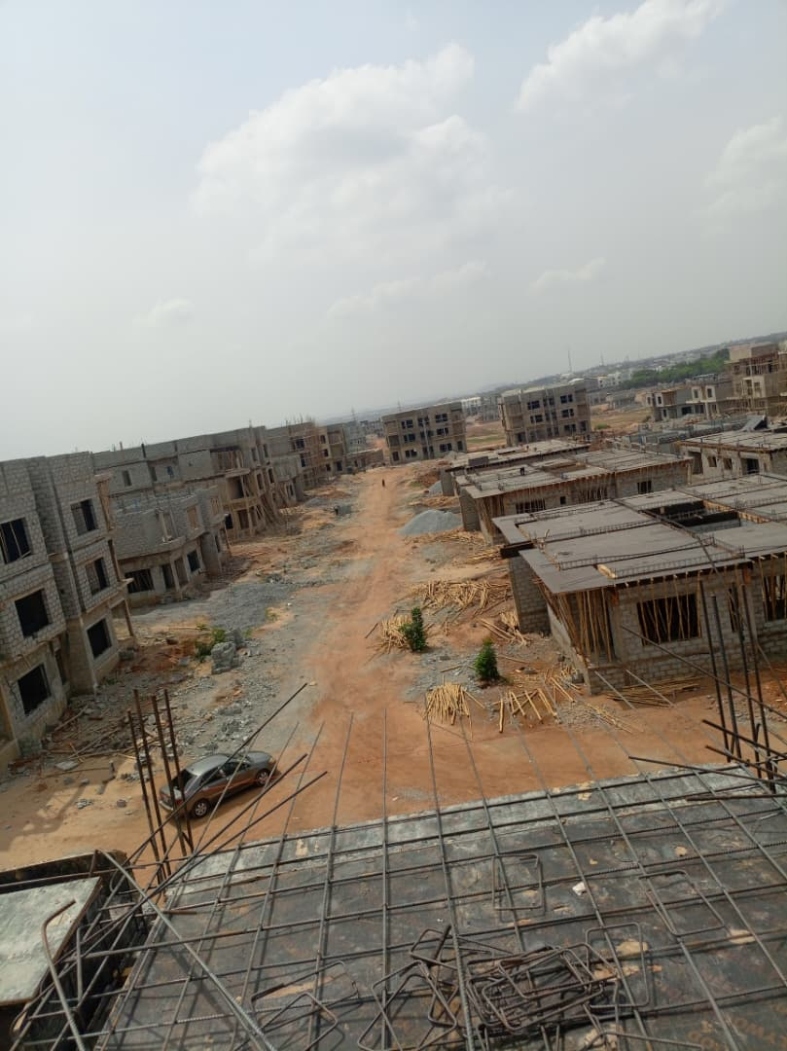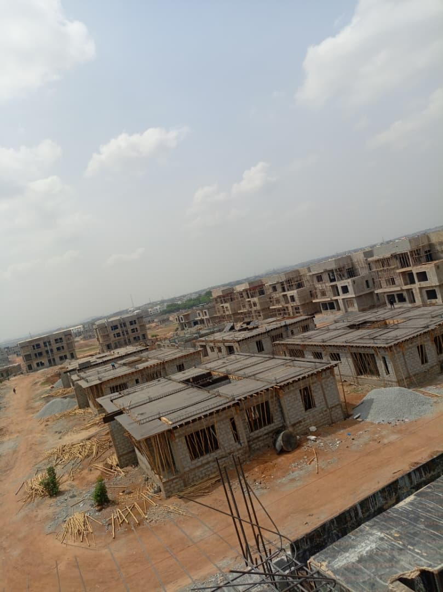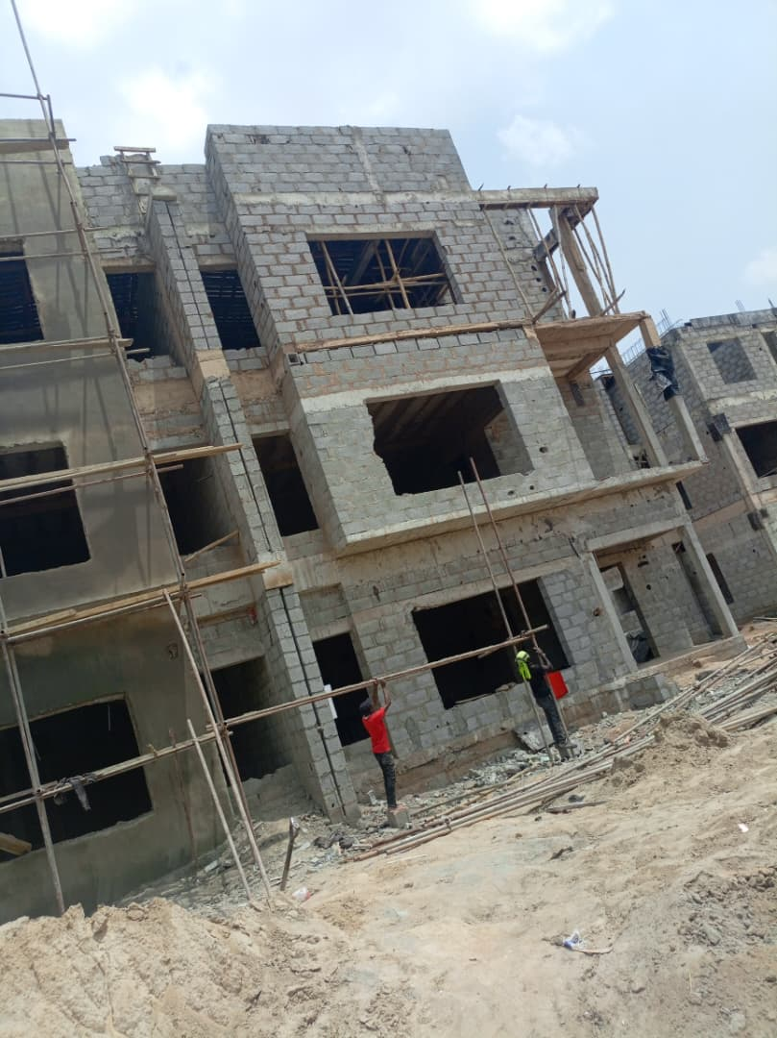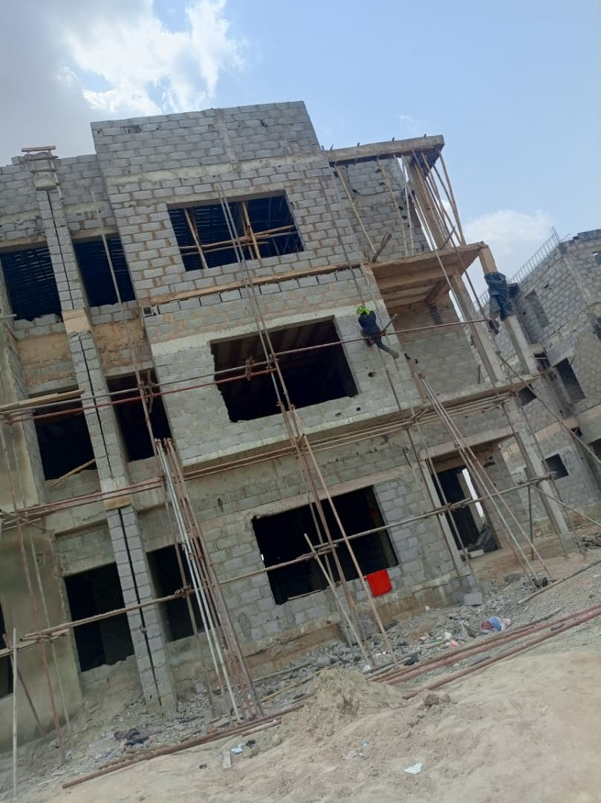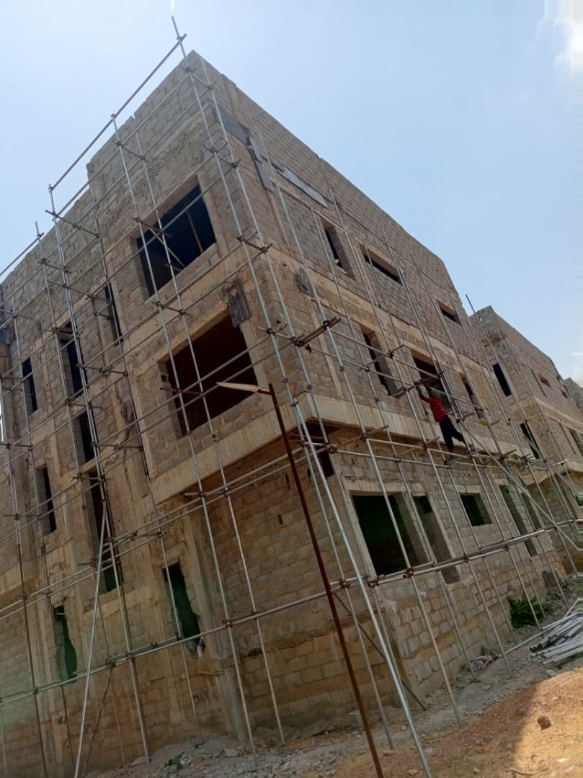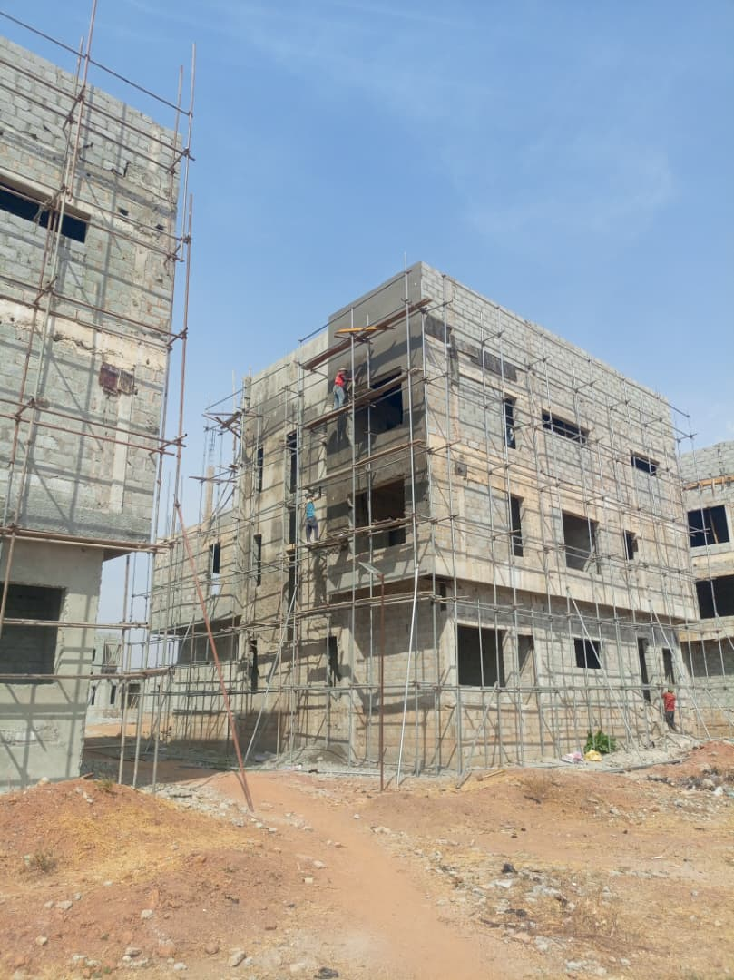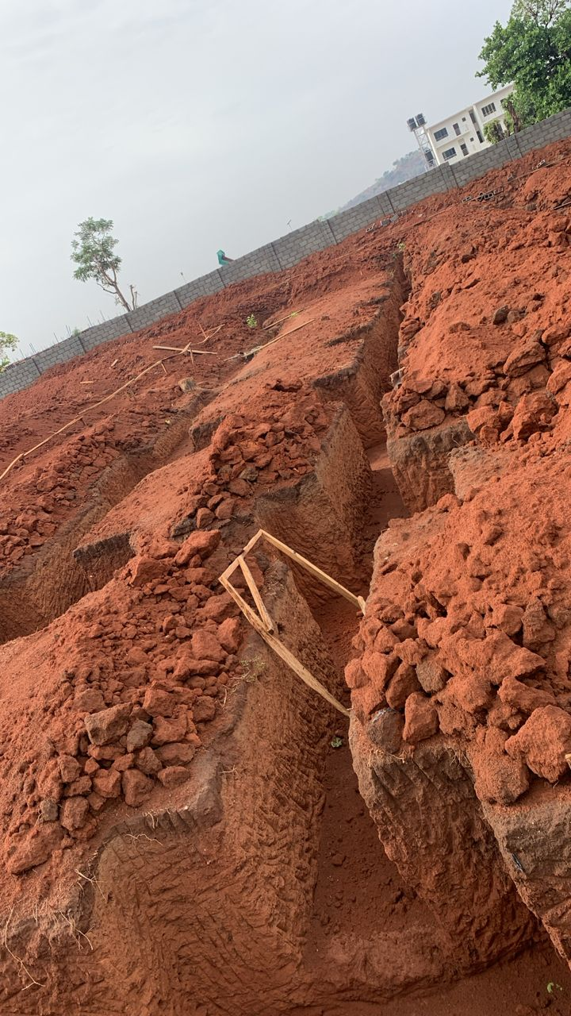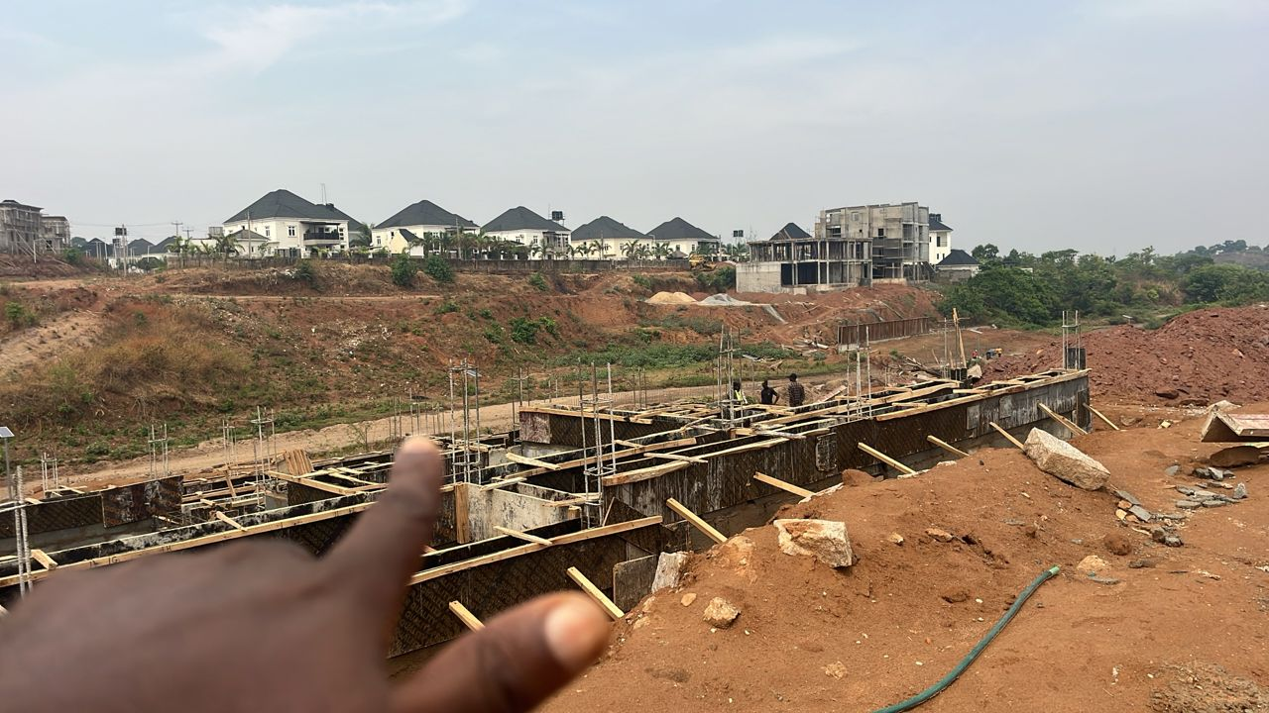

CONCLUSION
Rockcity Homes Limited is building toward a clear goal: to become one of Africa's leading real estate developers by delivering innovative, sustainable, and profitable developments that create lasting value for homeowners, investors, and communities. With a disciplined growth plan, a transparent approach to land and construction, and a clear focus on the segment of the market most in need of trustworthy developers, Rockcity Homes is positioned to grow alongside Nigeria's housing demand rather than compete only at its margins.

CONTACT INFORMATION
Channel | Detail
Company Name | ROCKCITY HOMES LIMITED
Head Office | [Insert office address],
Phone | 08062867870
WhatsApp | [Insert WhatsApp number]
Email | info@rockcityhomes.com
Website | rockcityhomeslimited.com

